**Guided Capstone Project Report**

**Executive Summary:**

* In this project, we seek how Big Mountain Resort distinguishes strategic decisions to optimize profitability and market competitiveness. Through rigorous data analysis and modeling, actionable recommendations are identified to drive revenue growth and enhance the resort's operating performance.

**Data-driven Recommendations:**

The data modeling focused on refining predictive models to optimize ticket prices. Initial linear models demonstrated high R-squared values but suffered from overfitting. Through feature selection and hyperparameter tuning, the random forest model is distinguished as the superior choice due to its lower Mean Absolute Error (MAE) and higher generalizability.

**Random Forest Model Insights:**

The random forest model identified significant predictors of ticket prices, including fast quads, number of runs, snowmaking area, and vertical drop. These features demonstrated strong correlations with ticket prices, consistent with findings from the linear model.

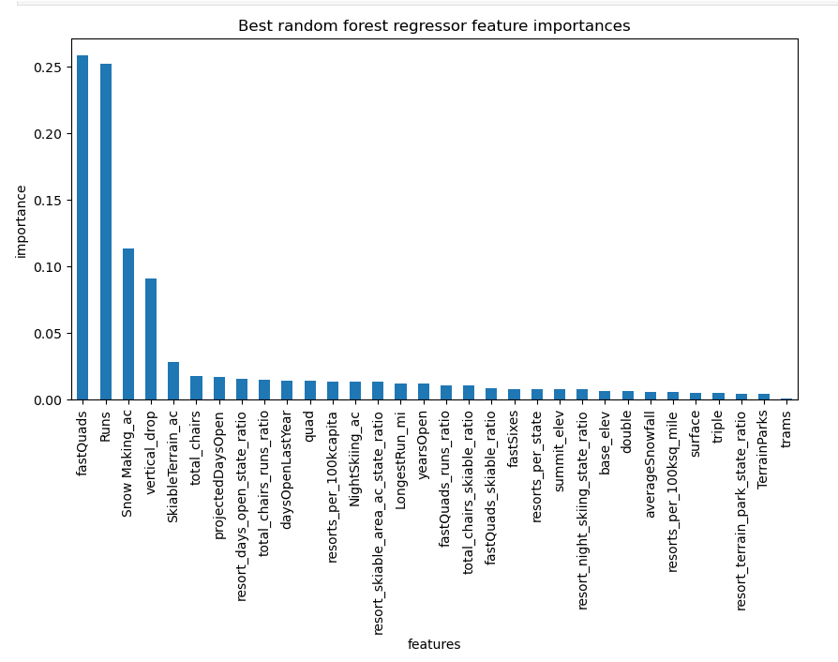

The current adult weekend ticket price at Big Mountain is 81.00 dollars. Our model suggests that Big Mountain's facilities could potentially support a higher ticket price. The model predicts a price of 95.87 dollars for Big Mountain.

However, we should be cautious to take the analysis results. The model's prediction has an expected mean absolute error, meaning the actual supported price could be higher or lower than $95.87.

**Scenario Analysis and Recommendations:**

Utilizing the random forest model, various scenarios were evaluated to assess their impact on revenue and profitability. Among these scenarios, I would recommend further consideration of the scenario, "Increasing Vertical Drop with Additional Chair Lift." This scenario offers a clear improvement in ticket price by $1.99 and revenue by $3,474,638 indicating its potential to enhance the overall profit of the resort.

**Conclusion:**

In conclusion, leveraging the insights from the random forest model, Big Mountain Resort can make informed decisions to optimize ticket prices and enhance profitability. By focusing on strategic initiatives such as expanding the vertical drop and the number of chair lifts, the resort can capitalize on its strengths and position itself for sustained success in the competitive ski resort market.